Varun Krishna – Ascendeum Assignment Submission

Sharable Looker Studio report link to dashboard - [click here](https://lookerstudio.google.com/reporting/800533b5-2d8d-4451-86ed-283aaef38330)

### Dashboard Look:

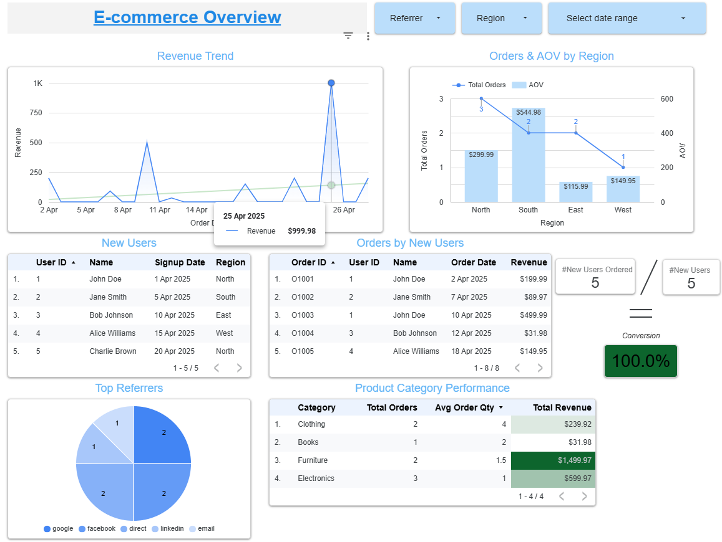

## Dashboard Creation:

#### Data:

The data for users, products, orders, page_views were contained in 4 different sheets and was fed into a single Google Sheets workbook.

#### Connect & Blend:

The data present in each of the sheets in Google Sheets workbook was fed into Looker Studio separately this creating 4 different datasets one for each of the users, products, orders and page_views data.

The data from these 4 datasets was blended using appropriate joining conditions. All the sheets were blended into one data using full outer join. This was done to avoid multiple blends and for the ease of analysis. The blended data source was named “Final Source Data”.

#### Building the “E-commerce Overview” Report:

All the requirements provided in the instructions document were addressed along with the appropriate headings and measures.

1. **Monthly Revenue Trend:** 
   * Metrics Created:
     1. Revenue = price (from products table) * quantity (from orders table)
   * Since the original data contained only one month’s data, there was no scope to visualize the monthly trend.
   * The revenue per each ordered date was visualized on a time series graph for the available month of data and additionally a trend was included in the graph to understand the overall trend of revenue.
   * The overall trend of the revenue turned out to have a positive slope i.e., revenue is on a upward trend.
   * 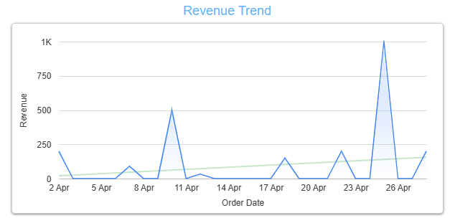
2. **Orders & AOV by Region:**
   * Metrics Created:
     1. Total Orders = Count of distinct order_ids in the orders table
     2. Average Order Value (AOV) = Average of Revenue generate in the Region
   * The data was visualized in combo chart
   * A graph with numbers and lines

     AI-generated content may be incorrect.
3. **New User Conversion Funnel:**
   * Key Constraint: All the calculations in this requirement should be based on the selected range of dates. Hence, all the metrics used for this requirement were created satisfying the constraint.
   * Metrics Created:
     1. New Users = COUNT_DISTINCT( case when signup_date is not null then user_id (Users) end)
     2. New Users Ordered = COUNT_DISTINCT( CASE WHEN signup_date IS NOT NULL AND order_id IS NOT NULL THEN user_id (Users) END )
     3. Conversion = New Users Ordered/ New Users
   * The conversion percentage was colour coded with Conditional Formatting to demonstrate the strength of conversion.
   * A screenshot of a computer

     AI-generated content may be incorrect.
   * A screenshot of a computer

     AI-generated content may be incorrect.
4. **Top Referrers:**
   * The data in the background was already blended thus attributing each order to its first referrer.
   * The pie chart visual shows the count of orders per each referrer.
   * A blue circle with white text

     AI-generated content may be incorrect.
5. **Product Category Performance:**
   * Metrics Created:
     1. Total Revenue = SUM(price*quantity)
     2. Total_Orders = COUNT_DISTINCT(order_id)
     3. Average Quatity per Order = AVG(quantity)
   * The Total Revenue column was conditional formatted to show the distinction between highest and subsequent revenue driving categories.
   * A screenshot of a product category

     AI-generated content may be incorrect.

#### Interactivity & Polish:

1. Global Data Range Control was added A blue rectangle with black arrow

   AI-generated content may be incorrect.
2. Filters for Region & Referrer were added
3. Drill-down from region into user-level details for the region graph was added
   1. 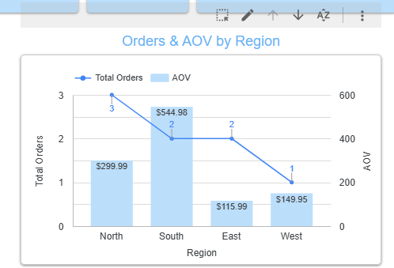
   2. A screenshot of a graph

      AI-generated content may be incorrect.
4. Consistency in styling, labels, and chart titles was maintained.

#### Bonus:

Month-over-Month revenue growth – Our of scope as data is small

Schedule report to email weekly – Done